Adjustable LED Spot Light

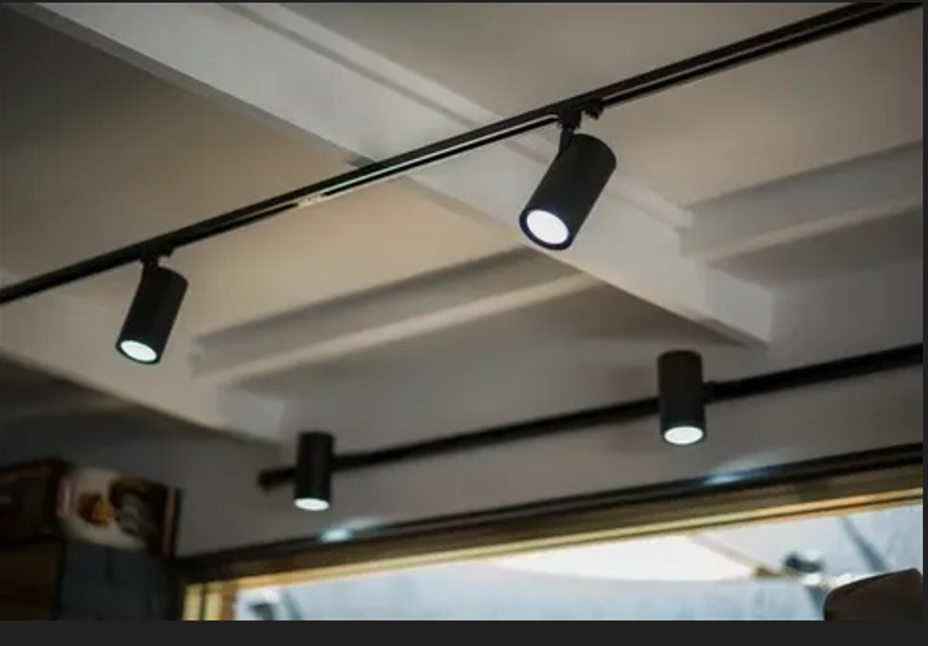

#### ****Description:****

**Adjustable LED Spot Lights** are versatile, energy-efficient lighting solutions designed to provide focused and directional light. These lights are perfect for highlighting specific areas or objects, such as artwork, architectural features, or retail displays. With adjustable heads and a sleek design, these spotlights offer both functionality and style.

* **Technology:** LED.
* **Compatibility:** Standard E26/E27 base (fits most fixtures).
* **Bulb Type:** PAR20, PAR30, PAR38 (depending on the model).
* **Wattage:** 7W (equivalent to 50W incandescent), 12W (equivalent to 75W incandescent).
* **Lumens:** 600 lumens (7W), 1100 lumens (12W).
* **Color Temperature:** 2700K (warm white), 3000K (soft white), 4000K (cool white).
* **Dimmable:** Yes (select models).
* **Lifespan:** 25,000 hours.
* **Energy Efficiency:** Energy Star certified.
* **Beam Angle:** Adjustable (typically 15° to 60°).

#### ****Key Features:****

* **Adjustable Heads:** Allows you to direct light precisely where it’s needed.
* **Energy-Efficient:** Uses up to 85% less energy than traditional incandescent bulbs.
* **Focused Lighting:** Ideal for highlighting artwork, architectural features, or retail displays.
* **Dimmable Options:** Available in dimmable models for adjustable brightness.
* **Long Lifespan:** Lasts up to 25,000 hours, reducing the need for frequent replacements.
* **Sleek Design:** Modern and compact, suitable for both residential and commercial use.

#### ****Pricing:****

* **Single Spotlight (7W, PAR20):** $14.99
* **Single Spotlight (12W, PAR30):** $19.99
* **Single Spotlight (12W, PAR38):** $24.99
* **4-Pack (7W, PAR20):** 49.99(49.99(12.50 per bulb)
* **4-Pack (12W, PAR30):** 69.99(69.99(17.50 per bulb)
* **4-Pack (12W, PAR38):** 89.99(89.99(22.50 per bulb)

#### ****Where to Use:****

* **Art Galleries:** Highlight artwork with precise, focused lighting.
* **Retail Stores:** Showcase products with bright, adjustable spotlights.
* **Living Rooms:** Accentuate architectural features or decor.
* **Kitchens:** Provide task lighting for countertops and workspaces.
* **Outdoor Spaces:** Illuminate pathways, gardens, or outdoor decor.

### ****Customer Reviews:****

* ⭐⭐⭐⭐⭐ "These Adjustable LED Spot Lights are fantastic! They provide bright, focused light, and the adjustable heads make it easy to direct the light exactly where I need it." – Sarah L.
* ⭐⭐⭐⭐ "Great value for the price. The lights are bright, and the dimming feature is smooth and reliable. Highly recommend for anyone looking to upgrade their lighting." – James T.
* ⭐⭐⭐⭐⭐ "I love how energy-efficient these spotlights are. The adjustable heads are perfect for highlighting my artwork." – Emily R.

### ****How to Order:****

1. Visit our website: [www.brightworldlighting.com](http://www.brightworldlighting.com/)
2. Select your preferred spotlight type and pack size (Single or 4-Pack).
3. Add to cart and proceed to checkout.
4. Enjoy free shipping on all orders over $50!

### ****Warranty and Support:****

* **Warranty:** 2-year limited warranty covering manufacturing defects.
* **Customer Support:** Contact us at [support@brightworldlighting.com](mailto:support@brightworldlighting.com) or call +1-800-123-4567 for assistance.

### ****Visual Representation:****

Include high-quality images of the Adjustable LED Spot Lights in different settings (e.g., art gallery, retail store) to showcase their versatility and design.